The Board of Workers’ Rights Watch is composed of dedicated 12 professionals with diverse backgrounds in labor rights, social justice, law, gender equality, and health. Together, they provide strategic direction, oversight, and governance to ensure the organization remains true to its mission of promoting fair, safe, and dignified working conditions for all. Their collective expertise and commitment guide our efforts to empower workers, influence policy, and drive systemic change.

1.Mr. Edward Inzofu Indimuli

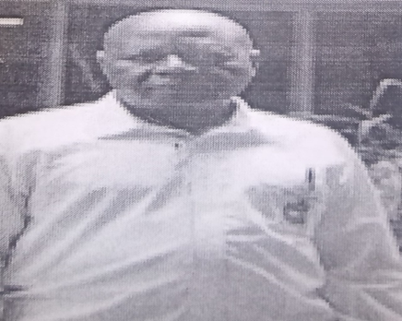

Chairman

Mr. Indimuli is a senior shop steward of the workers union at the branch level and is responsible for representing the workers’ rights at the branch level, He is an experienced social worker and a seasoned activist with diverse background covering social and community development.

Mr. Indimuli is currently serving as the Kakamega County Ombudsman defending the vulnerable workers and fighting corruption.

Mrs. Eunice Waweru

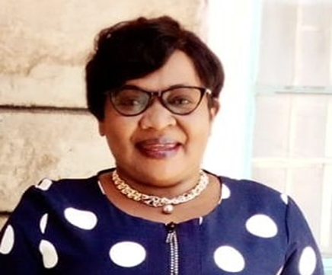

Chief Executive Officer

Mrs. Waweru is renowned human rights activist and an established social worker with a passion for addressing societal injustice. She has vast experience in matters human rights and social justice.

Miss Monica Wanjiku

1. 

Treasurer

Miss Monica Wanjiku is a chief shop steward of the workers union at the industry level. She is responsible for negotiation for Collective Bargain Agreements& dispute resolution at the industry level. His role is critical in creating harmony and mobilization of workers within the industry.